**This document covers 42 essential Linux and DevOps commands, syntax explanations, and practical examples. It is designed for beginners as well as professionals preparing for Linux and DevOps roles.**.

**1. Create a user techie and give sudo access**

* **Commands:**

Bash

sudo useradd -m techie

sudo passwd techie

sudo usermod -aG sudo techie

* **Explanation:** sudo gives you Admin powers. useradd -m creates a new user with their own folder. passwd sets their secret code. usermod -aG sudo adds them to the "Admin Team."

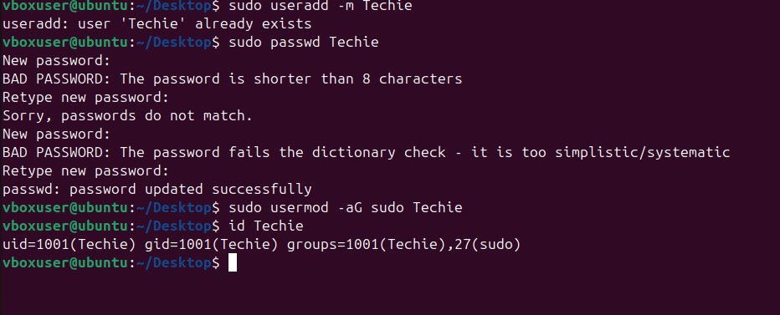

**2. Navigate to home directory**

* **Command:** cd ~
* **Explanation:** cd means Change Directory. The ~ symbol is a shortcut for your personal home folder.

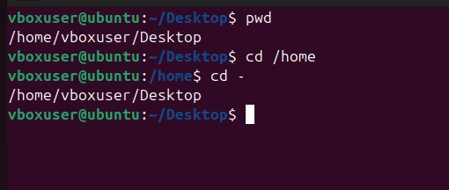

**3. Create a new directory**

* **Command:** mkdir myfolder
* **Explanation:** mkdir is short for "Make Directory." It creates a new folder.

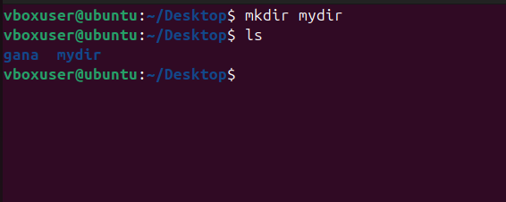

**4. List contents of a directory**

* **Commands:** ls or ls -l
* **Explanation:** ls shows what's inside. Adding -l (long) shows extra details like file size and who owns it.

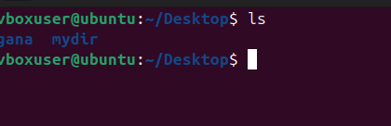

**5. Change current directory**

* **Command:** cd myfolder
* **Explanation:** This moves you "inside" the folder so you can work on the files there.

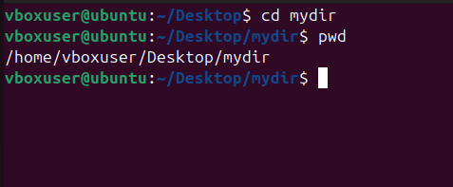

**6. Create an empty file**

* **Command:** touch file1.txt
* **Explanation:** Creates a brand new, empty text file instantly.



**7. View file contents**

* **Commands:** cat file1.txt or less file1.txt
* **Explanation:** cat dumps the whole text on your screen. less lets you scroll through it like a page.

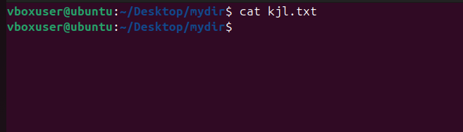

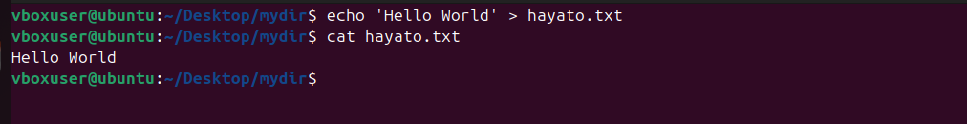

**8. Copy a file**

* **Command:** cp file1.txt /tmp/
* **Explanation:** cp makes a duplicate. The original stays put, and a new copy appears in the /tmp folder.

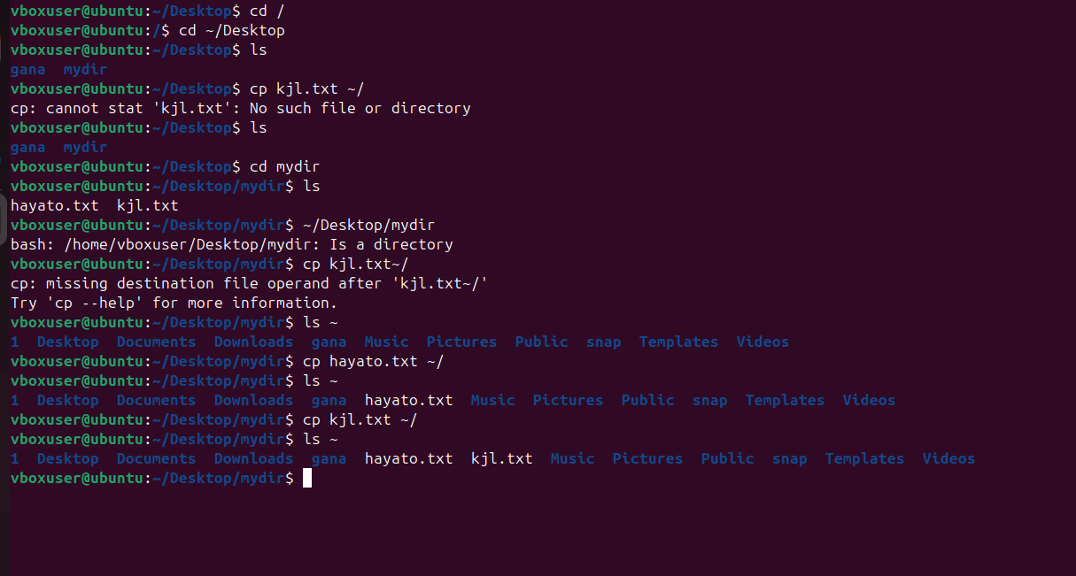

**9. Move a file**

* **Command:** mv file1.txt /tmp/
* **Explanation:** mv stands for move. It cuts the file from one place and pastes it in another.

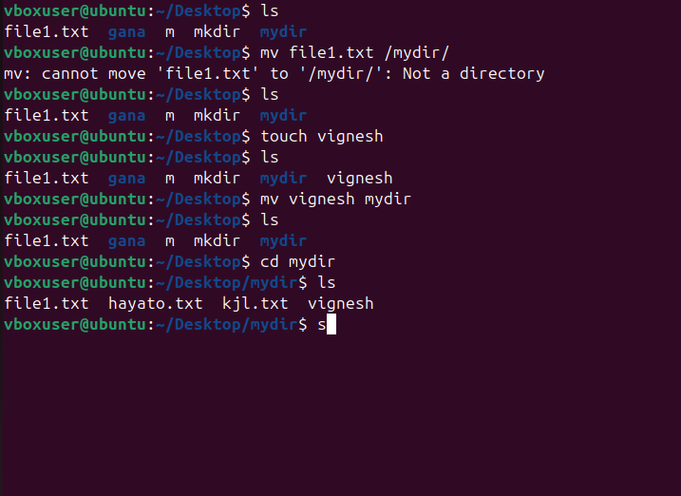

**10. Rename a file**

* **Command:** mv old.txt new.txt
* **Explanation:** In Linux, "renaming" is just moving a file to a new name in the same spot.

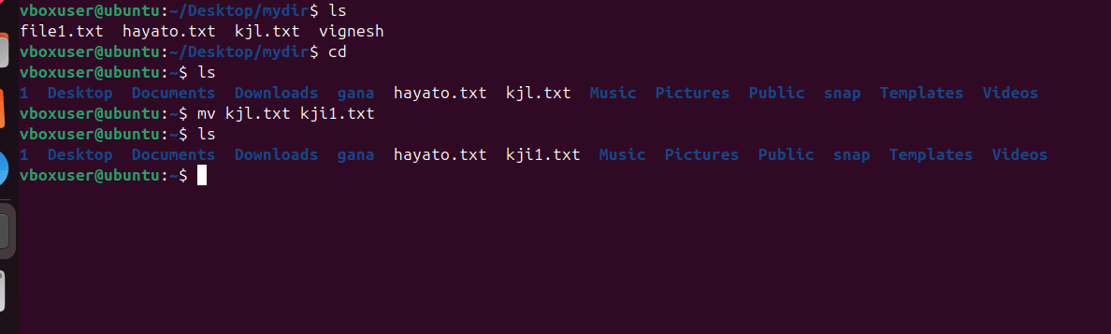

**11. Delete a file**

* **Command:** rm file1.txt
* **Explanation:** rm means remove. **Wa rning:** There is no "Recycle Bin"; once deleted, it's gone.

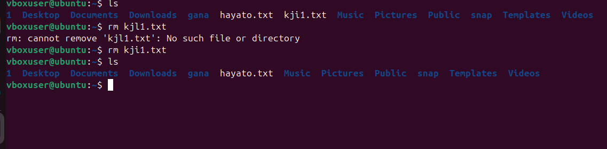

**12. Grant / revoke permissions**

* **Command:** chmod 755 script.sh
* **Explanation:** chmod changes who can read, write, or run a file. 755 means the owner can do everything, while others can only read and run it.

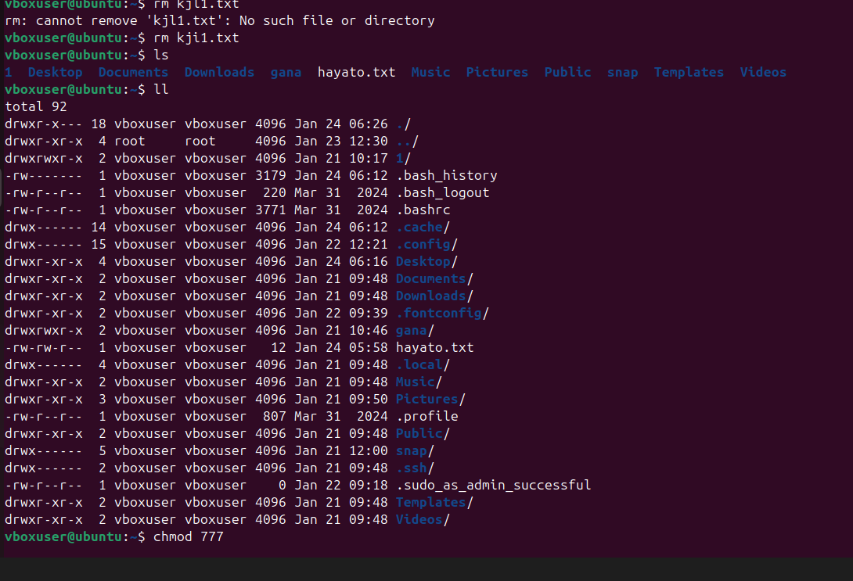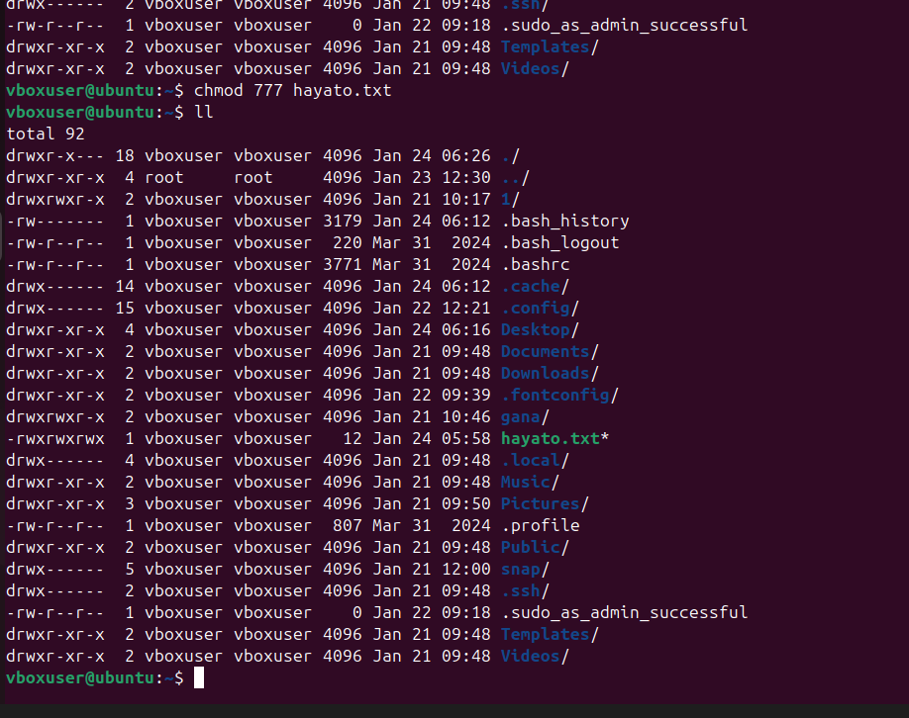

**13. View current date & time**

* **Command:** date
* **Explanation:** Shows the current time and day on the computer.

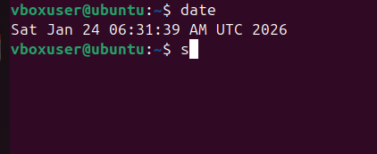

**14. Check system uptime**

* **Command:** uptime

**Explanation:** Tells you how long the computer has been "awake" since the last restart

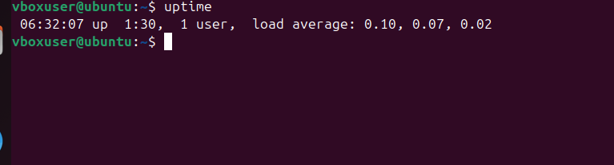

**15. View running processes**

* **Commands:** ps -ef or top
* **Explanation:** ps is a snapshot of what’s running. top is like the "Task Manager" that updates live. 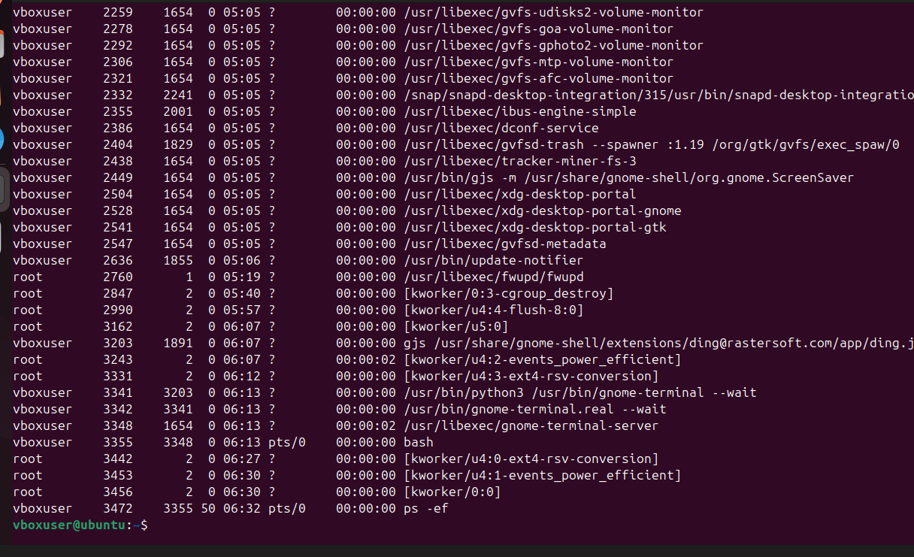

**16. Kill a process**

* **Commands:** kill 1234 or kill -9 1234
* **Explanation:** kill stops a stuck program. -9 is the "Force Stop" button.

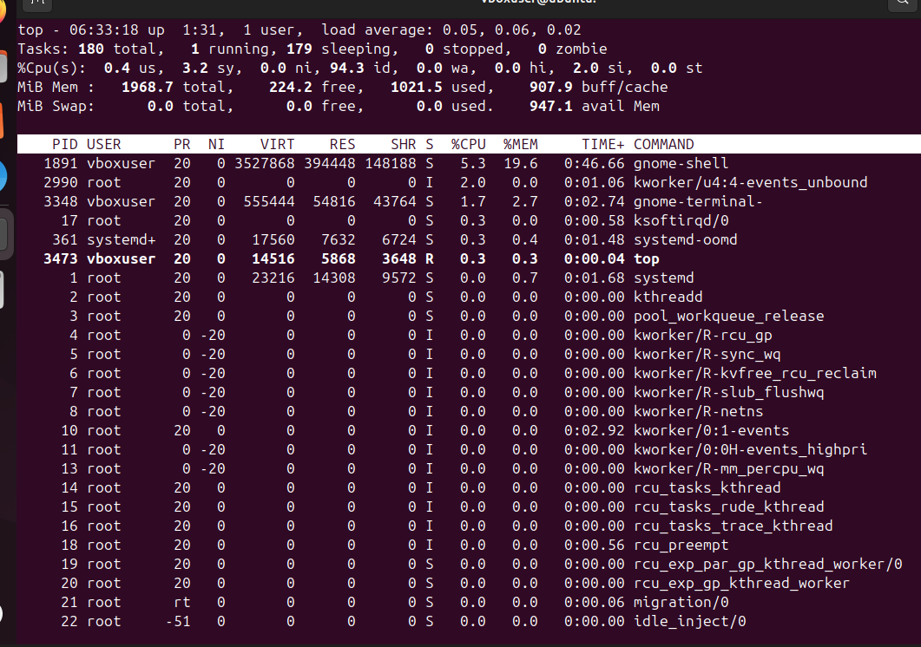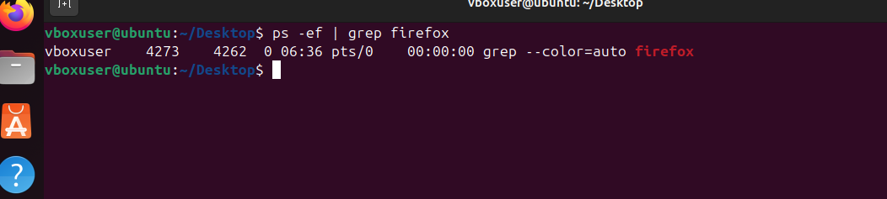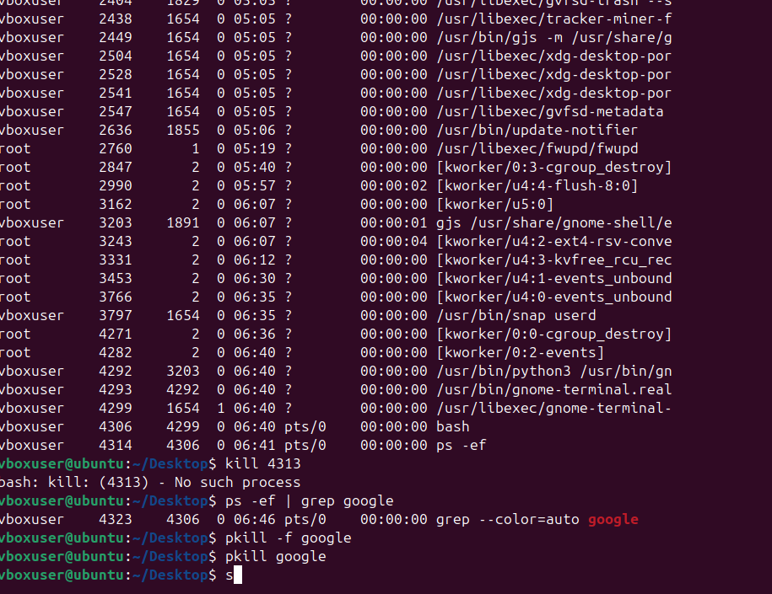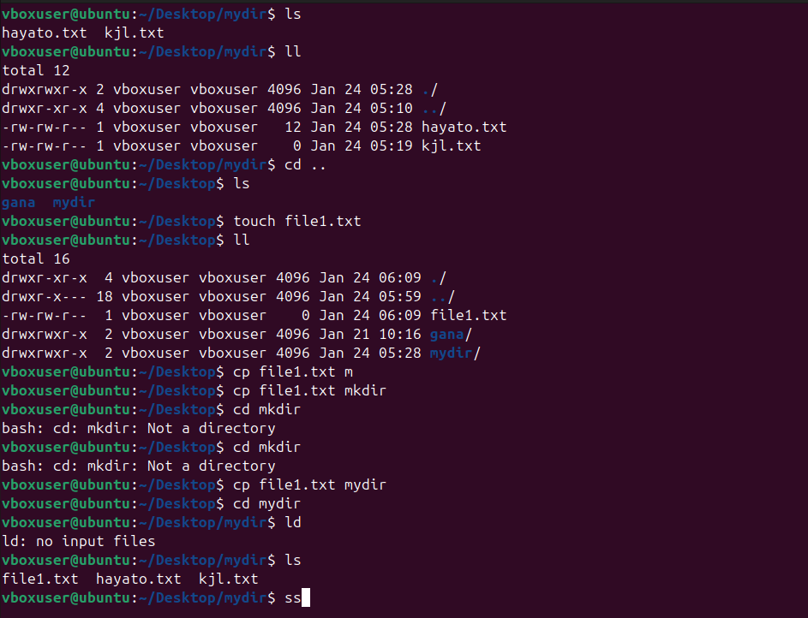**17. Install a package**

* **Command:** sudo apt install nginx -y
* **Explanation:** apt is the Linux App Store. -y says "Yes" to all questions automatically.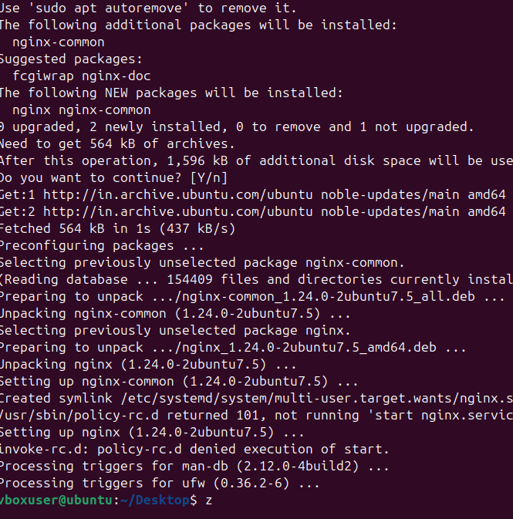

**18. Update system packages**

* **Command:** sudo apt update && sudo apt upgrade -y
* **Explanation:** This checks for updates and then installs them to keep the computer healthy.

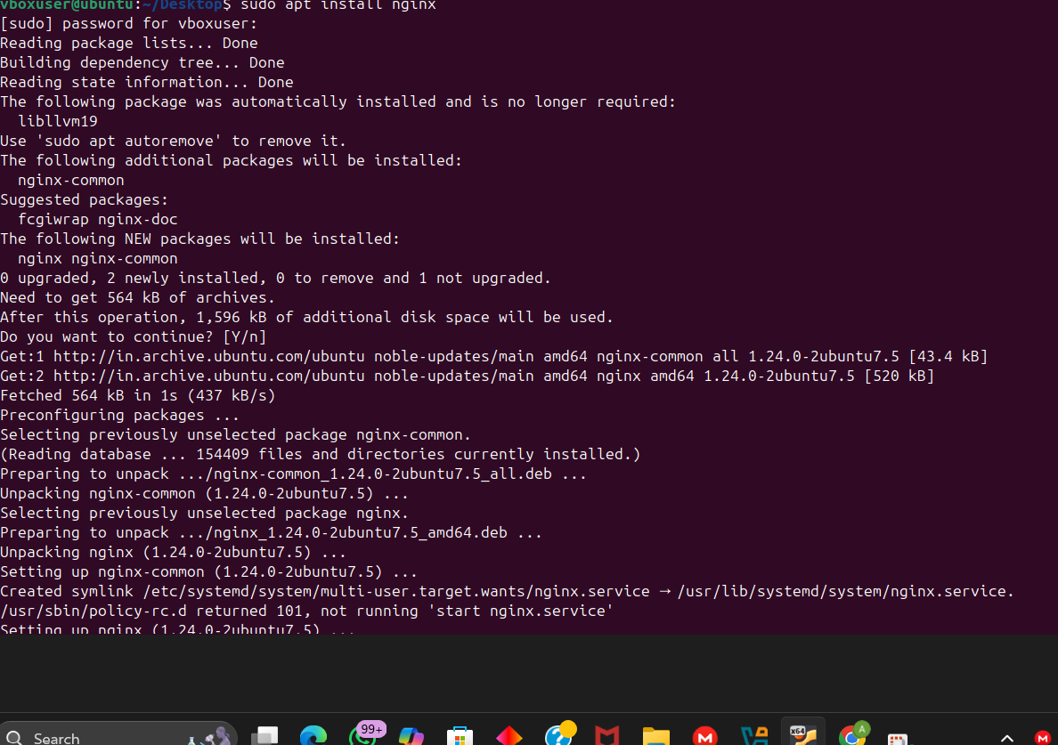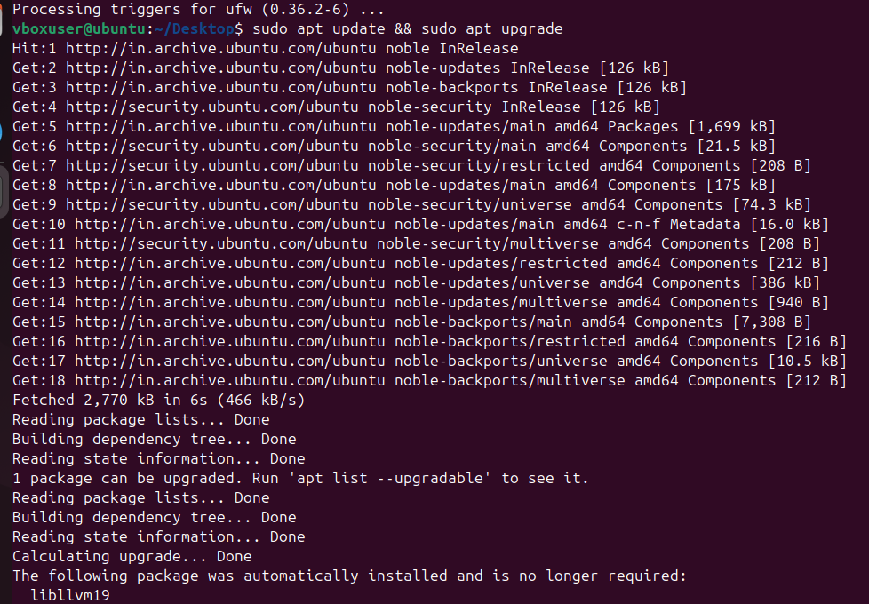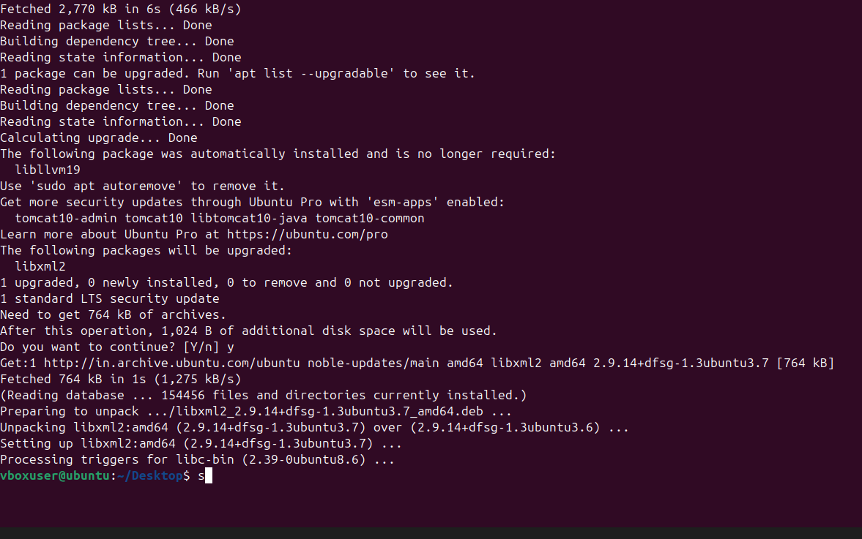

**19. Create a symbolic link**

* **Command:** ln -s /var/log/syslog syslog_link
* **Explanation:** This creates a "Shortcut" to a file. Clicking the shortcut takes you to the real file.

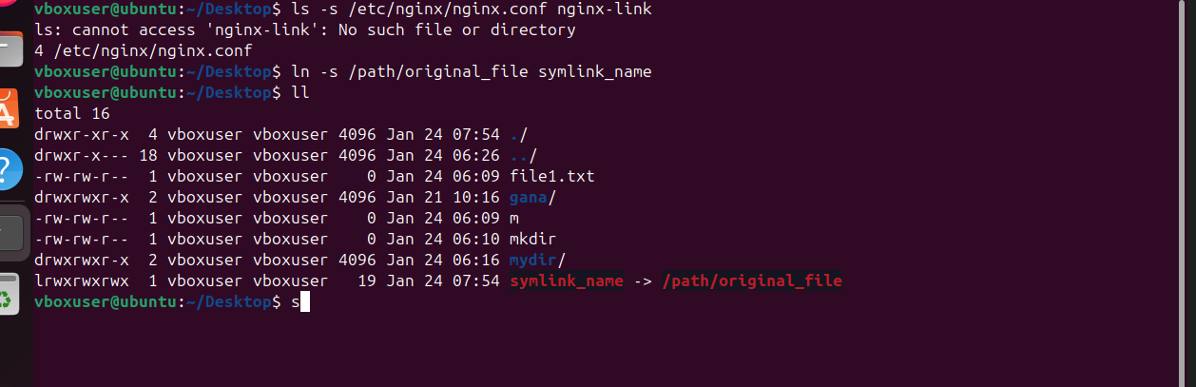

**20. Search files using find**

* **Command:** find / -name file.txt
* **Explanation:** Searches the whole computer for a specific file by its name.

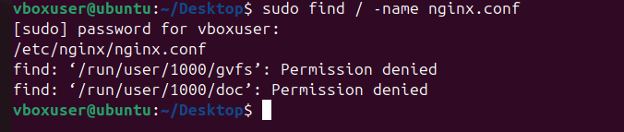

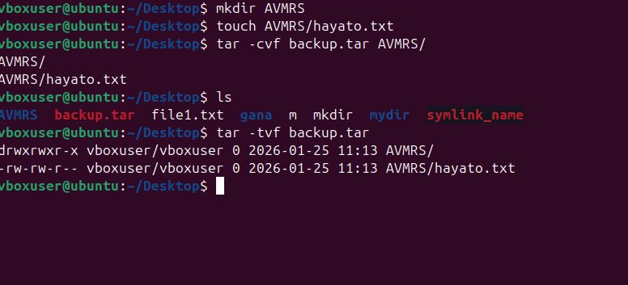

**21. Compress & decompress using tar**

* **Commands:** tar -cvf backup.tar folder/ | tar -xvf backup.tar
* **Explanation:** tar is used to bundle files together (like a ZIP). -c creates it, -x extracts it.

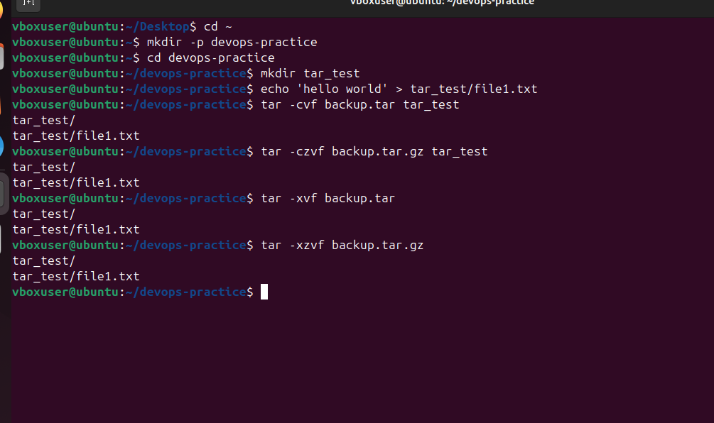

**22. Monitor system resources**

* **Commands:** top or htop
* **Explanation:** Shows how much "Brain power" (CPU) and "Memory" (RAM) the computer is using.

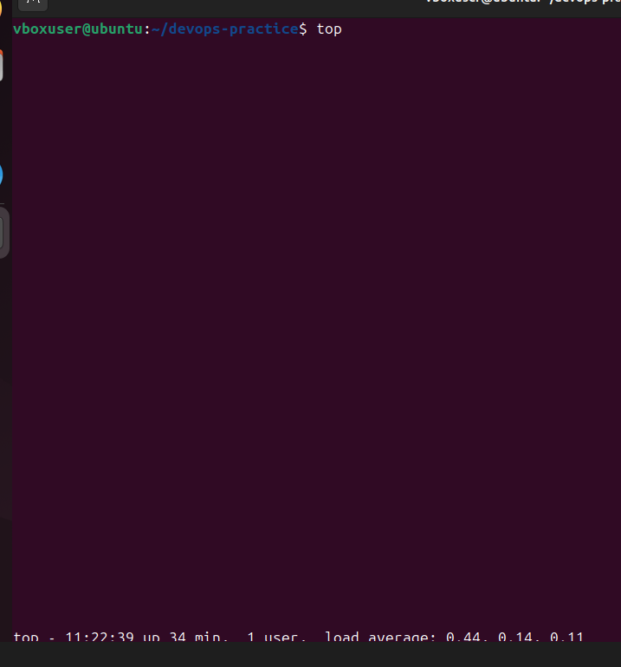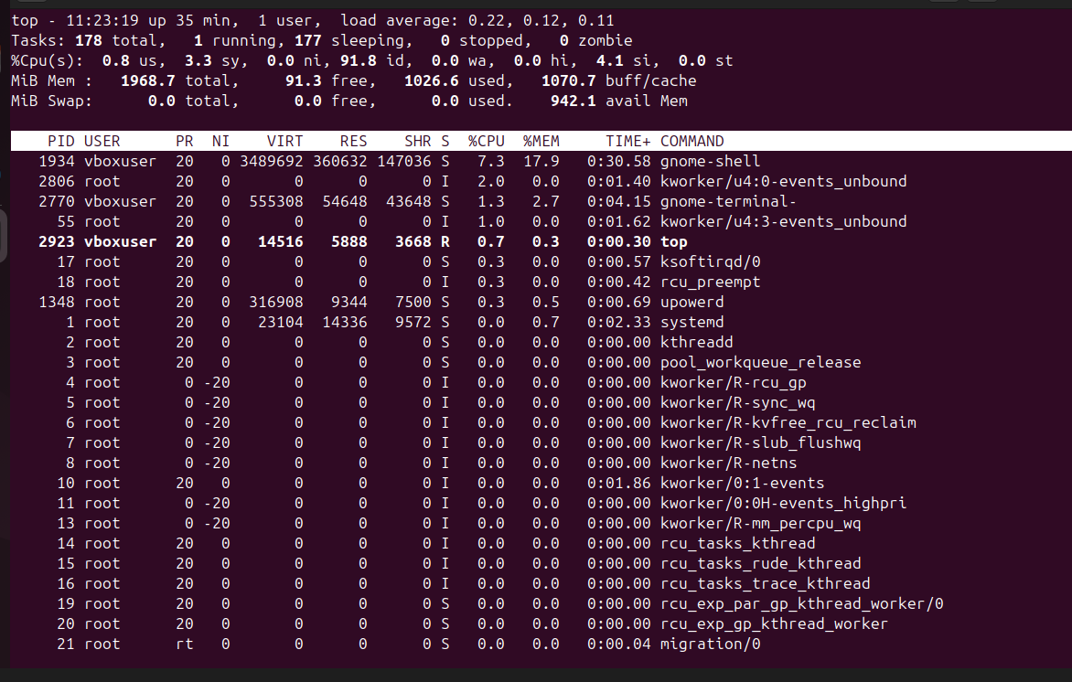**23. Create & manage groups**

* **Commands:** sudo groupadd devops | sudo usermod -aG devops techie
* **Explanation:** Creates a "Team" (group) and adds a user to that team so they can share access.

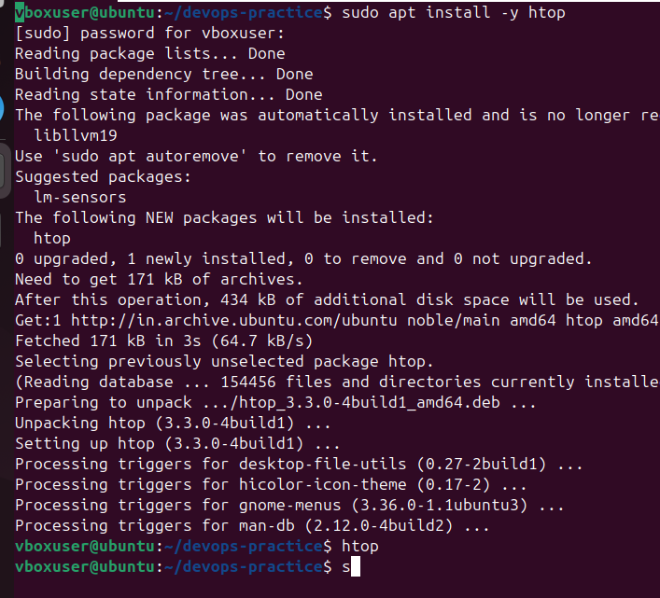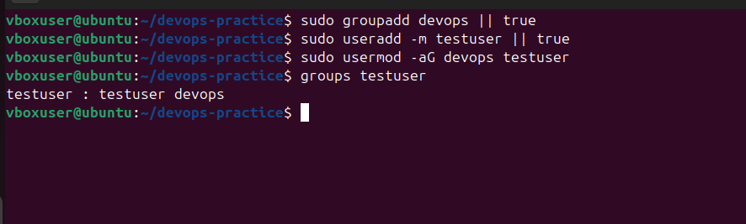

**24. SSH passwordless authentication**

* **Commands:** ssh-keygen | ssh-copy-id user@server_ip
* **Explanation:** This creates a digital "ID Card" so you can log into other computers without typing a password.

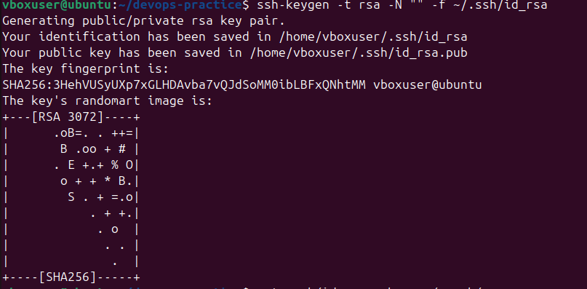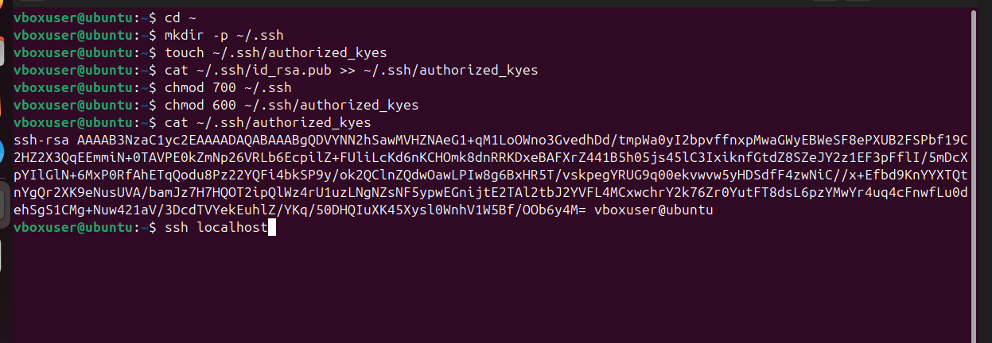

**25. Set up web server (Apache)**

**Command:** sudo apt install apache2 -y

**Explanation:** Installs software that lets your computer host a website.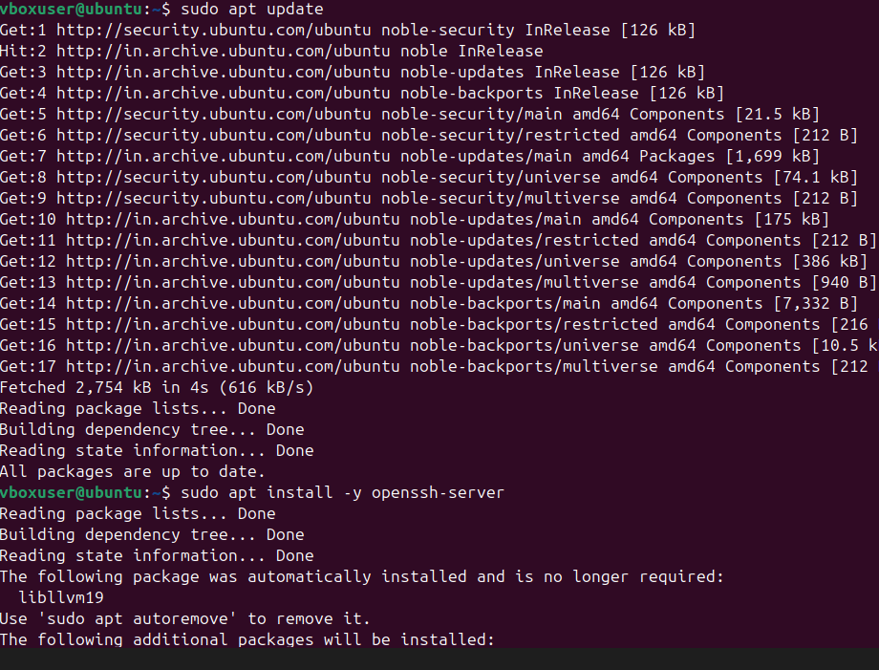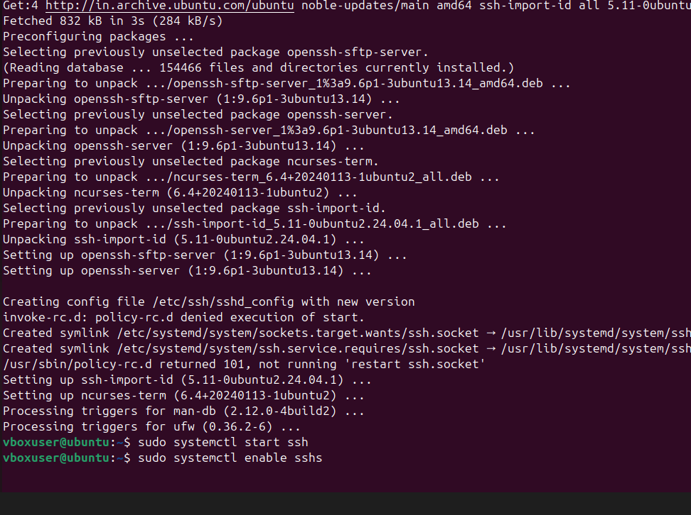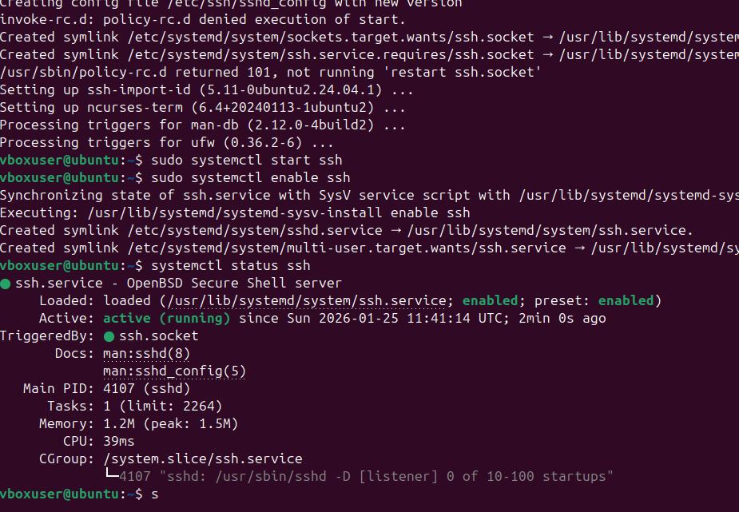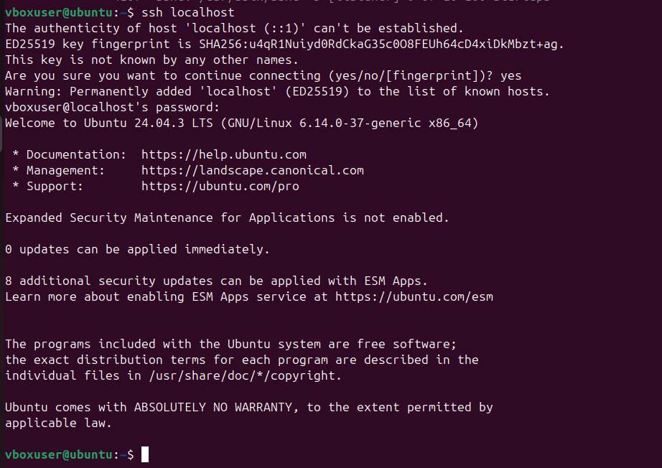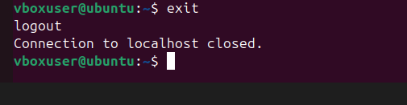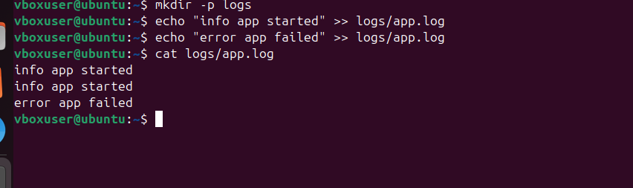

**26. Monitor logs using tail / grep**

**Commands**: tail -f /var/log/syslog | grep error /var/log/syslog

**Explanation:** tail -f lets you watch a file as it grows (live). grep searches for a specific word like "error."

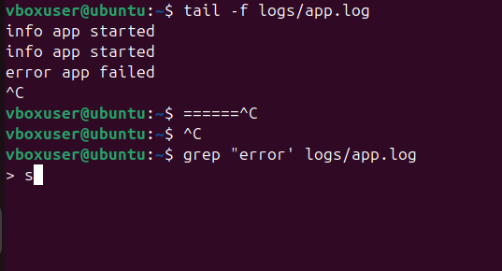

**27. Configure & secure MySQL**

* **Command:** sudo mysql_secure_installation
* **Explanation:** A setup wizard that adds a lock and key to your database to keep hackers out.

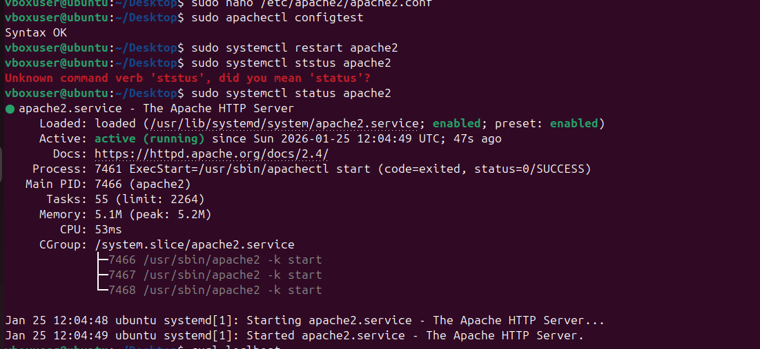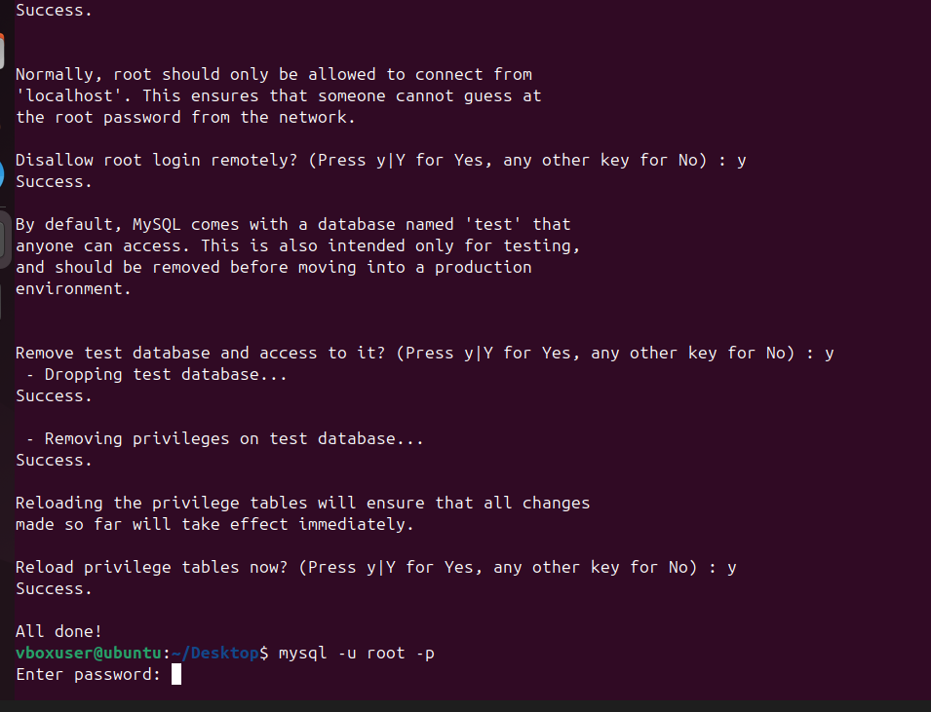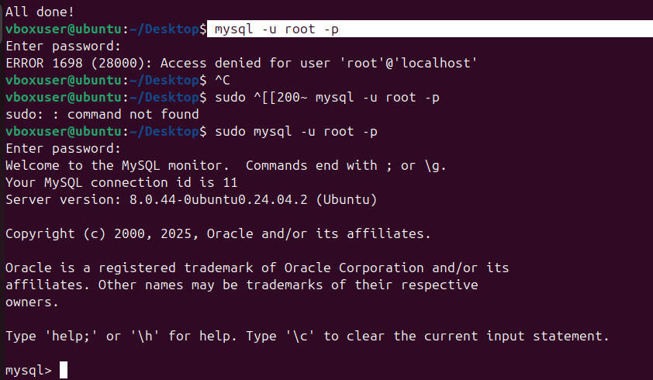

**28. Set up Apache Tomcat**

* **Command:** sudo apt install tomcat9 -y
* **Explanation:** Installs a special server used to run Java programs.

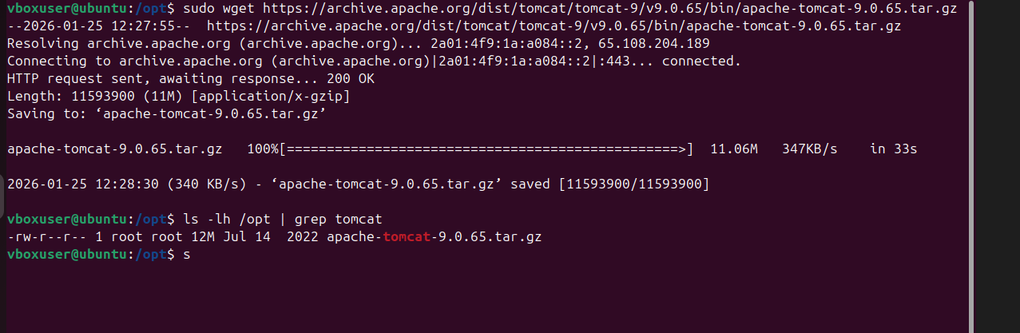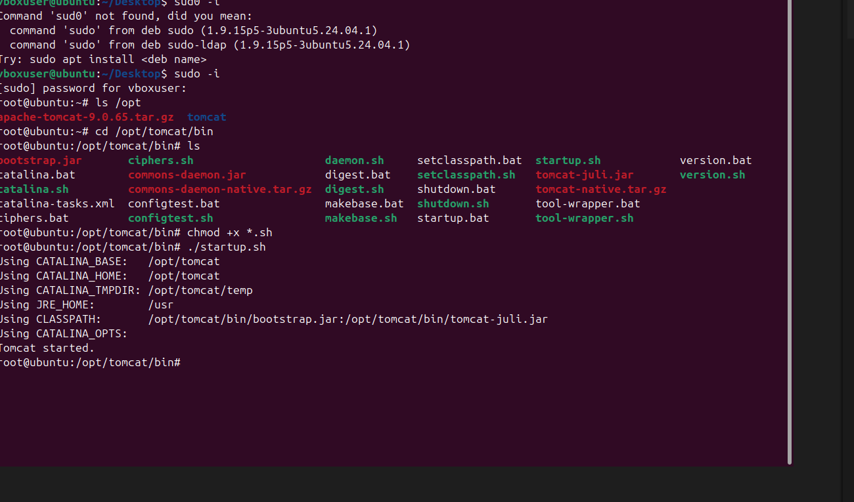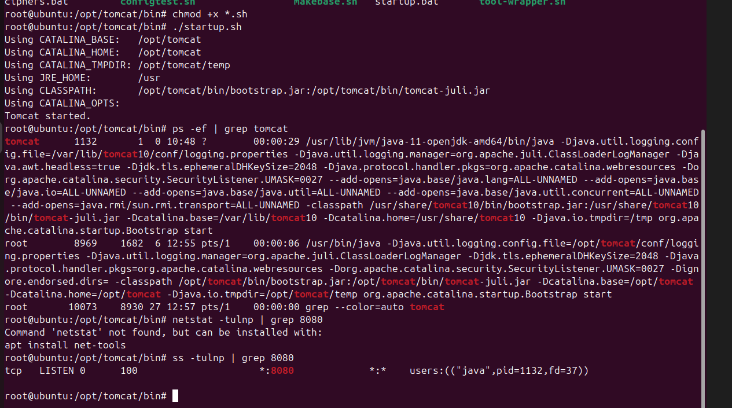

**29. Create Tomcat service file**

* **Commands:** sudo systemctl start tomcat9 | sudo systemctl enable tomcat9

**Explanation:** start turns it on now; enable makes sure it turns on automatically when the computer starts 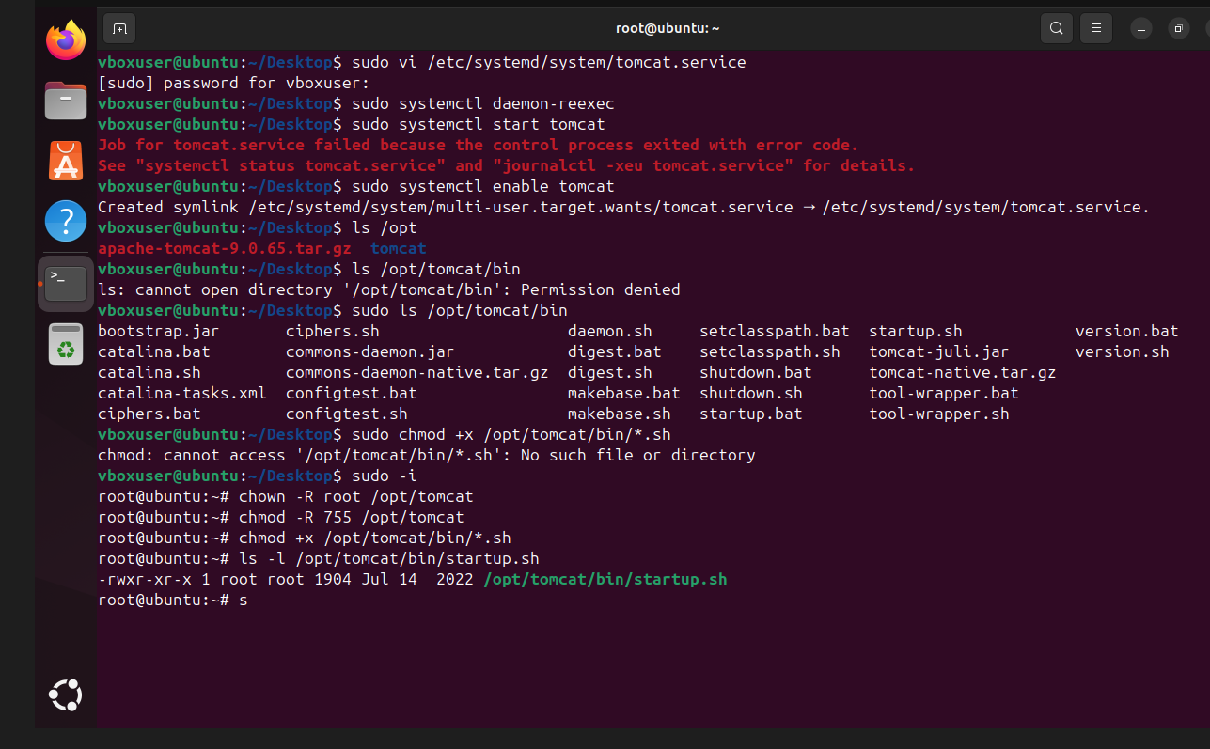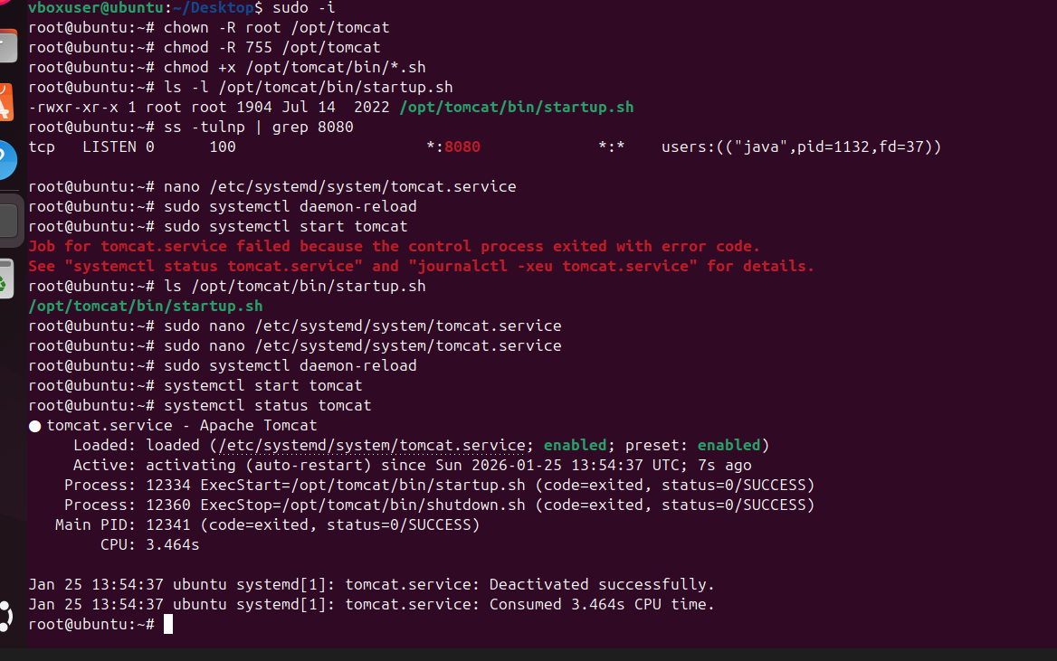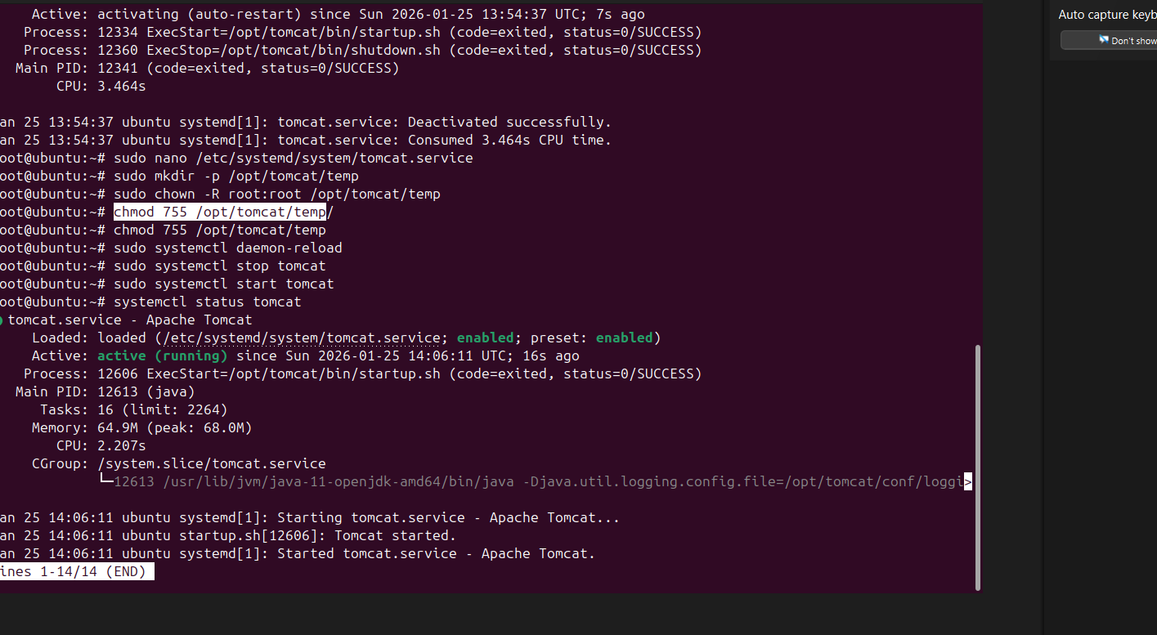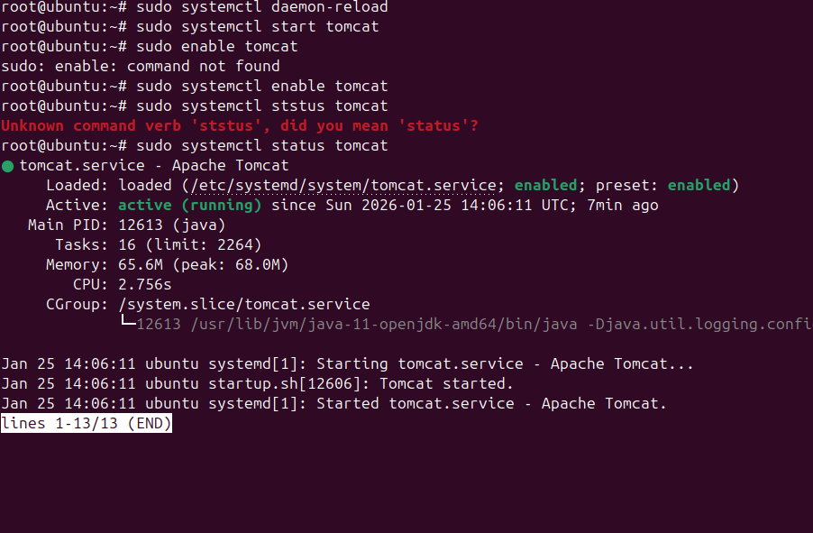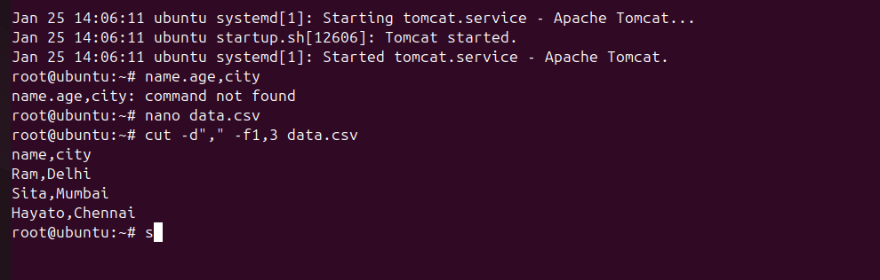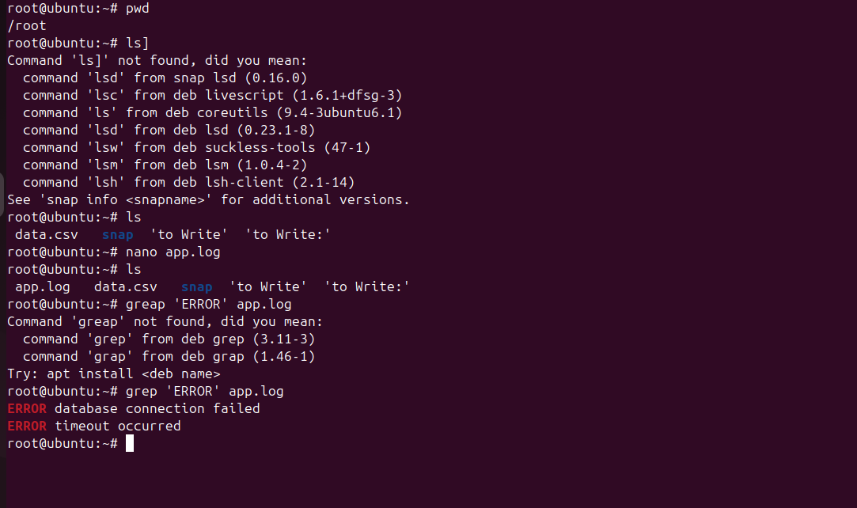

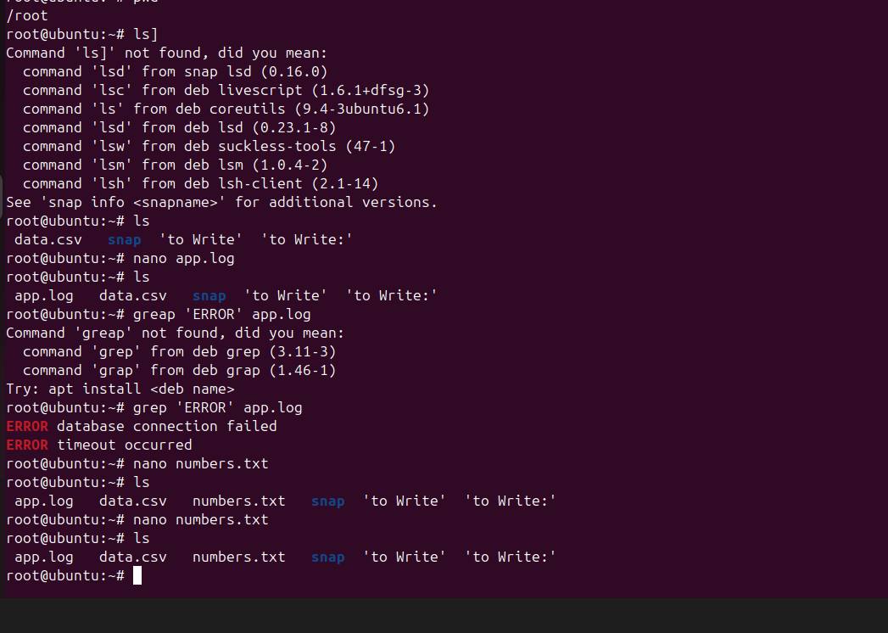

**30. Print specific columns**

* **Command:** awk '{print $1,$3}' file.txt
* **Explanation:** awk is like a spreadsheet tool. This says "Show me only column 1 and column 3."

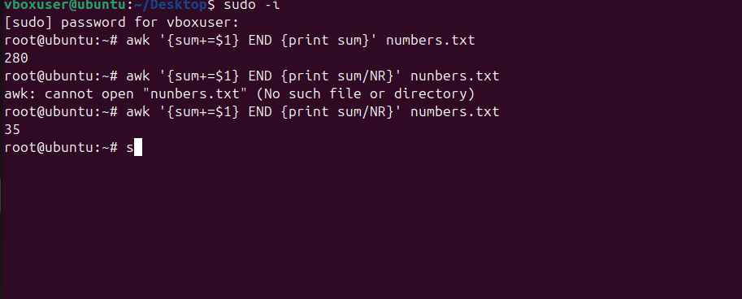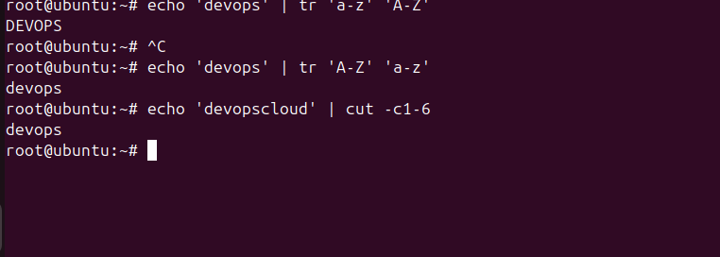

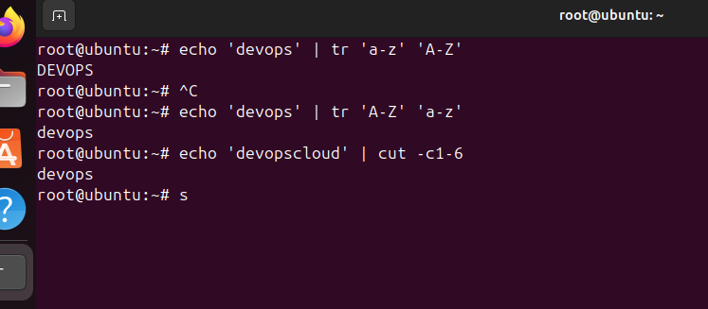

**31. Filter lines (pattern)**

* **Command:** grep "error" file.txt
* **Explanation:** Searches the file and shows ONLY the lines that have the word "error."

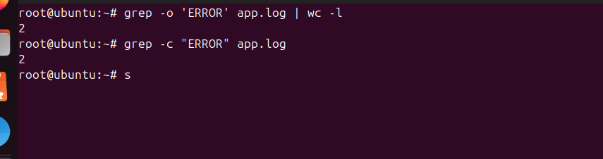

**32. Calculate sum / average**

* **Command:** awk '{sum+=$1} END {print sum}' file.txt
* **Explanation:** Adds up all the numbers in the first column and gives you the total.



**33. String manipulation**

* **Command:** awk '{print toupper($0)}' file.txt
* **Explanation:** Changes every letter in the file to **UPPERCASE**.

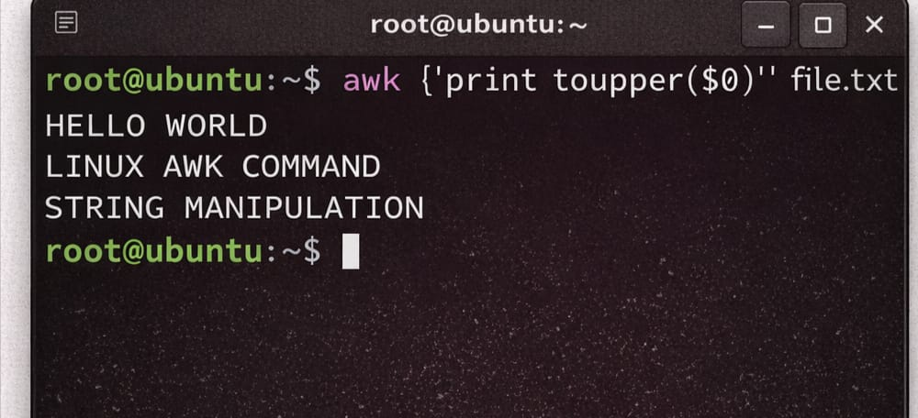

**34. Count occurrences**

* **Command:** grep -c "error" file.txt
* **Explanation:** Instead of showing the text, it just tells you the **number** of times "error" was found.

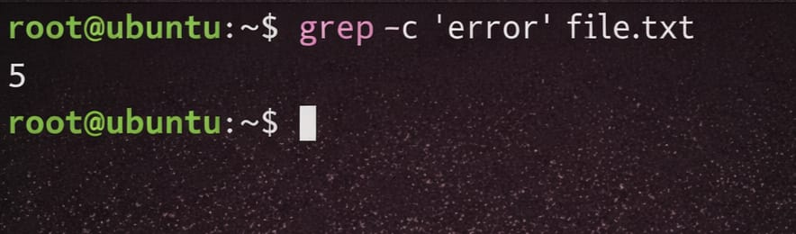

**35. Sort lines**

* **Command:** sort -k2 file.txt
* **Explanation:** Puts the lines in order (A-Z) based on what is in the 2nd column.

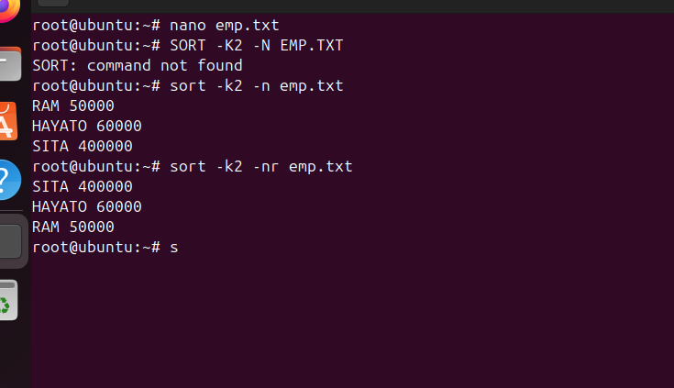

**36. Merge files**

* **Command:** paste file1.txt file2.txt
* **Explanation:** Glues two files together side-by-side (like columns in a table).

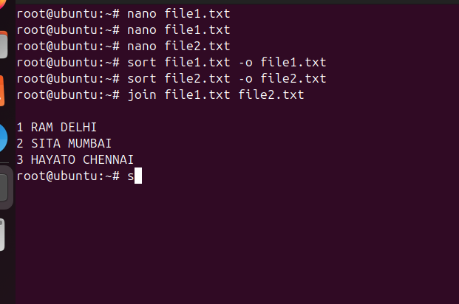

**37. Search & replace**

* **Command:** sed 's/old/new/g' file.txt
* **Explanation:** sed is a "Find & Replace" tool. This swaps every "old" word for "new."

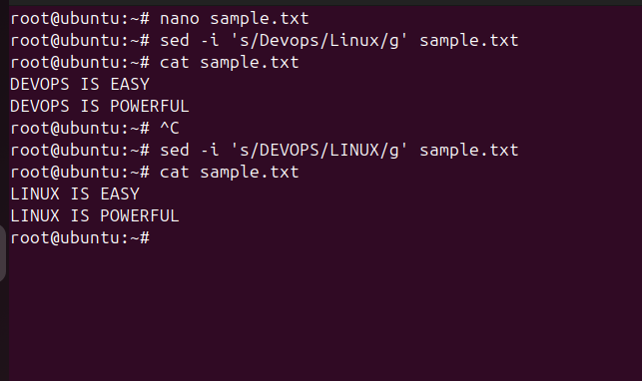

**38. Delete lines**

* **Command:** sed '5d' file.txt
* **Explanation:** Deletes line number 5 from the file.

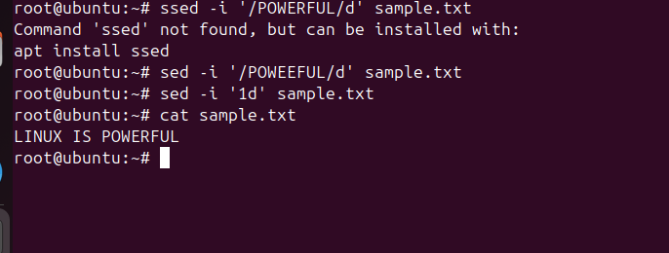

**39. Append / insert text**

* **Command:** sed '2a New Line' file.txt
* **Explanation:** Adds ("appends") a new line of text right after line number 2.

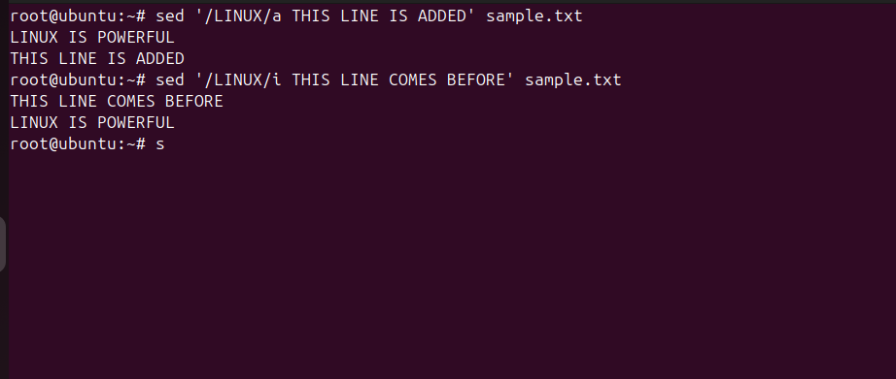**40. Print specific lines**

* **Command:** sed -n '3,5p' file.txt
* **Explanation:** Tells the computer: "Only show (print) lines 3, 4, and 5."

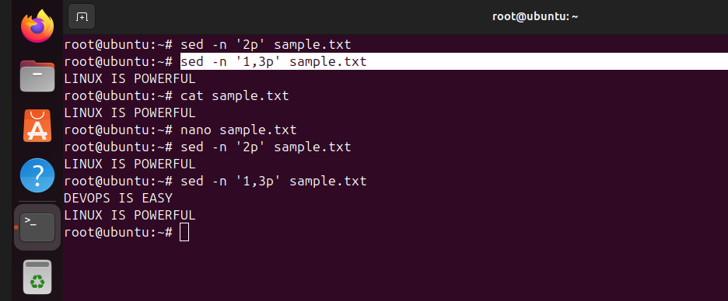

**41. Copy file from Linux to Windows**

* **Command:** scp file.txt user@windows_ip:/path
* **Explanation:** scp (Secure Copy) sends a file over the network to another computer safely.

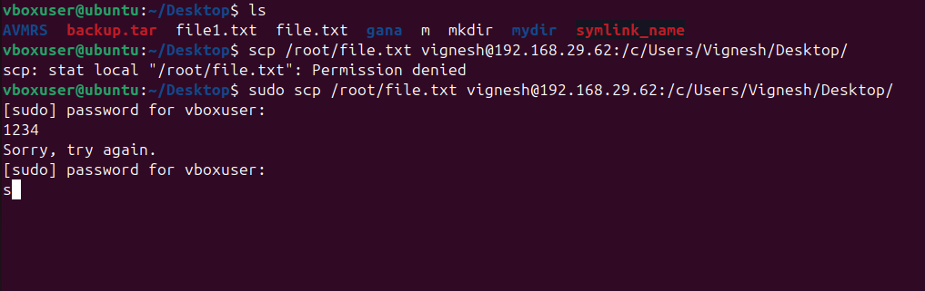

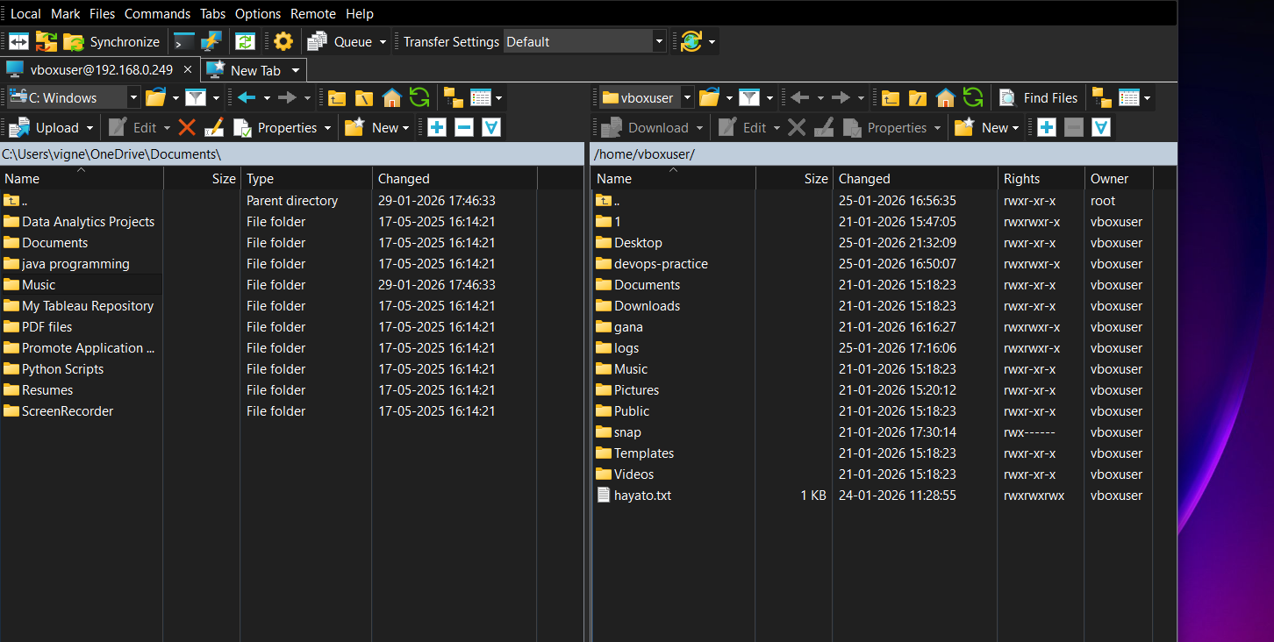

**42. AWK & SED Use Cases**

* **AWK (5):** Printing columns, Summing values, Filtering rows, Formatting output, Log analysis.

**SED (5):** Search & replace, Deleting lines, Inserting text, Editing config files, Automating edits

## 1. Create a User and Grant Sudo Access

```bash

sudo useradd -m techie

sudo passwd techie

sudo usermod -aG sudo techie

```

**Explanation:** `useradd -m` creates a user with a home directory. `passwd` sets the user password. `usermod -aG sudo` adds the user to the sudo group.

## 2. Navigate to Home Directory

```bash

cd ~

```

**Explanation:** `~` represents the current user’s home directory.

## 3. Create a New Directory

```bash

mkdir myfolder

```

**Explanation:** `mkdir` is used to create directories.

## 4. List Directory Contents

```bash

ls

ls -l

```

**Explanation:** `-l` displays a long listing including permissions, owner, and size.

## 5. Change Directory

```bash

cd myfolder

```

## 6. Create an Empty File

```bash

touch file1.txt

```

## 7. View File Contents

```bash

cat file1.txt

less file1.txt

```

**Explanation:** `less` provides a scrollable file view.

## 8. Copy a File

```bash

cp file1.txt /tmp/

```

## 9. Move a File

```bash

mv file1.txt /tmp/

```

## 10. Rename a File

```bash

mv old.txt new.txt

```

## 11. Delete a File

```bash

rm file1.txt

```

## 12. Grant and Revoke Permissions

```bash

chmod 755 script.sh

chmod 644 file.txt

```

**Explanation:** 7=rwx, 6=rw, 5=r-x.

## 13. View Current Date and Time

```bash

date

```

## 14. Check System Uptime

```bash

uptime

```

## 15. View Running Processes

```bash

ps -ef

top

```

## 16. Kill a Process

```bash

kill 1234

kill -9 1234

```

**Explanation:** `-9` forcefully terminates a process.

## 17. Install a Package

```bash

sudo apt install nginx -y

```

## 18. Update System Packages

```bash

sudo apt update && sudo apt upgrade -y

```

## 19. Create a Symbolic Link

```bash

ln -s /var/log/syslog syslog_link

```

## 20. Search Files Using find

```bash

find / -name file.txt

```

## 21. Compress and Decompress Using tar

```bash

tar -cvf backup.tar myfolder/

tar -xvf backup.tar

```

## 22. Monitor System Resources

```bash

top

htop

```

## 23. Create and Manage Groups

```bash

sudo groupadd devops

sudo usermod -aG devops techie

```

## 24. Configure SSH Passwordless Authentication

```bash

ssh-keygen

ssh-copy-id user@server_ip

```

## 25. Monitor Logs Using tail and grep

```bash

tail -f /var/log/syslog

grep error /var/log/syslog

```

---

## 26. Set Up Apache Web Server

```bash

sudo apt install apache2 -y

sudo systemctl start apache2

```

## 27. Configure and Secure MySQL

```bash

sudo apt install mysql-server -y

sudo mysql_secure_installation

```

## 28. Set Up Apache Tomcat

```bash

sudo apt install tomcat9 -y

```

## 29. Manage Tomcat Service

```bash

sudo systemctl start tomcat9

sudo systemctl enable tomcat9

```

## 30. Print Specific Columns

```bash

awk '{print $1,$3}' file.txt

```

---

## 31. Filter Lines by Pattern

```bash

grep "error" file.txt

```

---

## 32. Calculate Sum and Average

```bash

awk '{sum+=$1} END {print sum}' file.txt

```

## 33. String Manipulation

```bash

awk '{print toupper($0)}' file.txt

```

## 34. Count Occurrences

```bash

grep -c "error" file.txt

```

## 35. Sort Lines

```bash

sort -k2 file.txt

```

---

## 36. Merge Files

```bash

paste file1.txt file2.txt

```

## 37. Search and Replace

```bash

sed 's/old/new/g' file.txt

```

## 38. Delete Lines

```bash

sed '5d' file.txt

```

## 39. Append or Insert Text

```bash

sed '2a New Line' file.txt

```

## 40. Print Specific Lines

```bash

sed -n '3,5p' file.txt

```

## 41. Copy File from Linux to Windows

```bash

scp file.txt user@windows_ip:/path

```

## 42. AWK and SED Use Cases

**AWK:** Print columns, calculate sums, filter rows, format output, log analysis.

**SED:** Search and replace, delete lines, insert text, edit configuration files, automate file edits.

AWK (5):

1. Print columns

2. Sum values

3. Filter rows

4. Format output

5. Log analysis

SED (5):

1. Search & replace

2. Delete lines

3. Insert text

4. Edit config files

5. Automate file edits